Matlab Simulation Circuit:
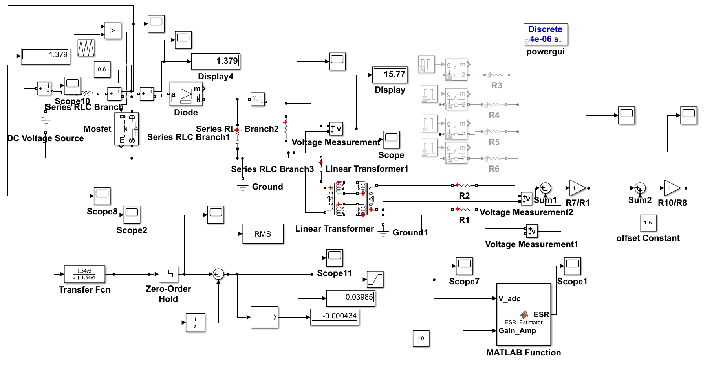
Output of Low Pass Filter
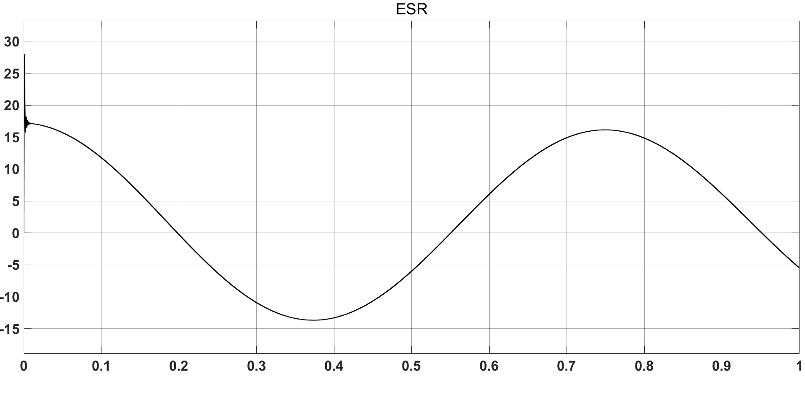

Output of Zero Order Hold:
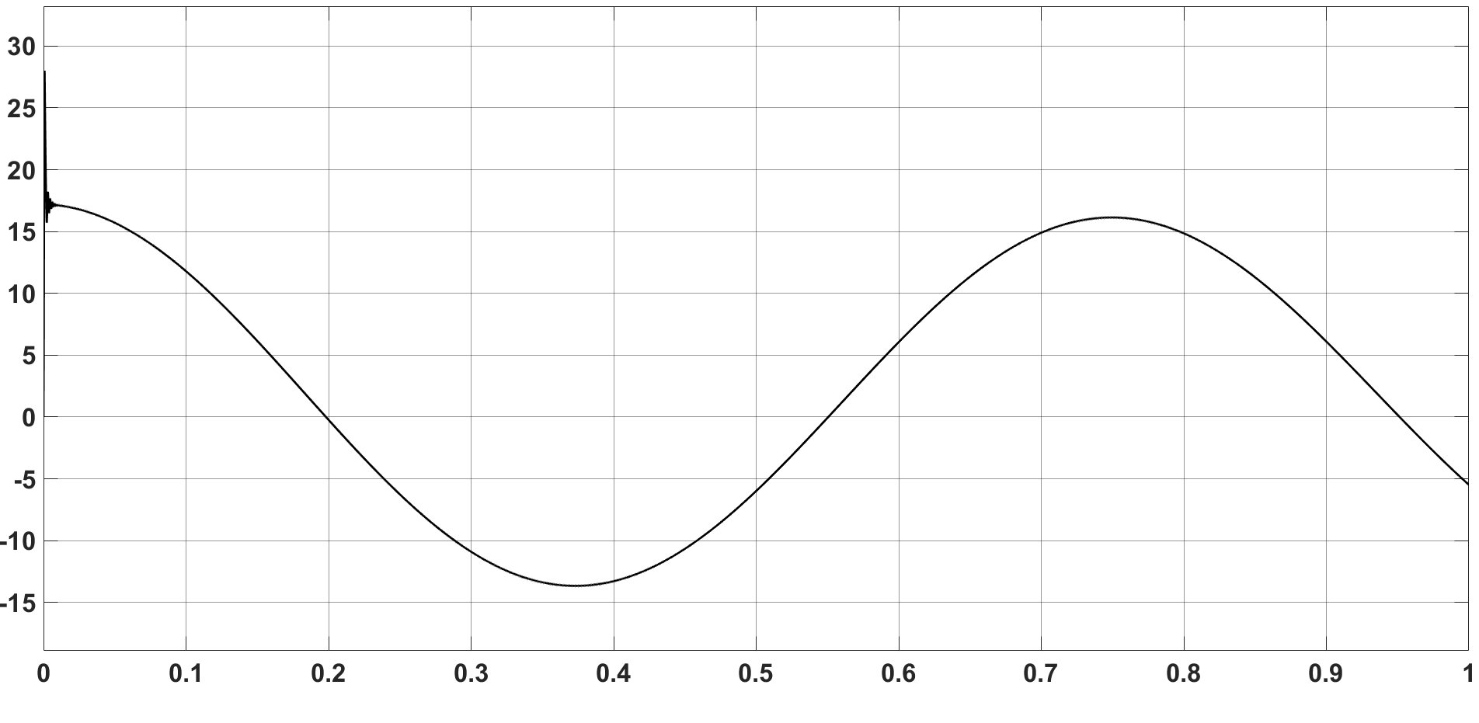

Matlab Function Code:
function ESR = ESR_Estimator(V_adc, Gain_Amp)

persistent ESR_filt

if isempty(ESR_filt)
ESR_filt = 0;
end

I_CAP_STEP = 0.3;

K = 10;

ESR_inst = (K * abs(V_adc)) / (Gain_Amp * I_CAP_STEP);

alpha = 0.05;
ESR_filt = alpha * ESR_inst + (1 - alpha) * ESR_filt;

ESR = ESR_filt;

End

Output of ESR after Matlab Function:
For ESR=0.1 ohm:
Output ESR:-
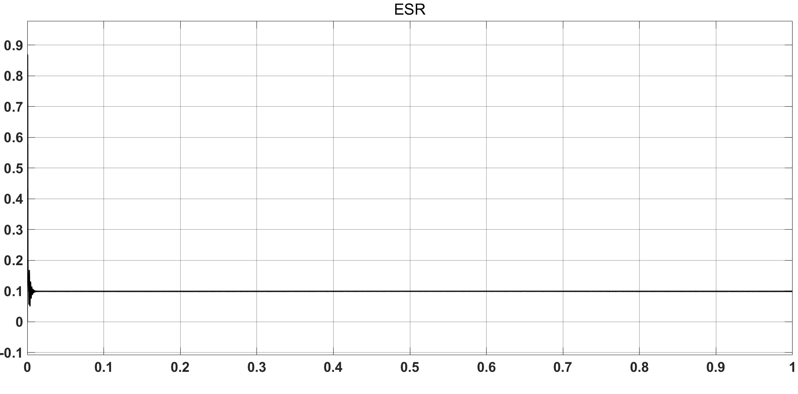

For ESR=0.5 ohm:
Output ESR:-
